Sub-Bids Requested for:
I-90 Cabin Creek Interchange to West Easton Interchange Project
(Phase 3 – Add Lanes/Wildlife Bridges)
Owner: WSDOT
Condition of Award Goals  Small Business Enterprise: 5%  Veteran-Owned Business: 3% | Voluntary Goals  Minority Business Enterprise: 10%  Women Business Enterprise: 6%
Bid Date: May 11th, 2022, at 11:00 AM PDT
Subcontractor Bids Requested: May 6th, 2022, at 10:00 AM PDT
Atkinson is bidding the above referenced Bid-Build project as a prime contractor. We are committed to supporting, assisting, and providing equal opportunity to SVBE and MWBE Business Enterprises. In furthering that commitment, we invite all Subcontractors and Suppliers to bid on the referenced project. If you require information or assistance regarding obtaining certifications and registration, or any related service, please call our office.
Project Description: The purpose of this Project is to provide critical improvements along Interstate 90 from the Cabin Creek interchange to West Easton interchange. The Project is focused on a six-mile road widening from an existing four lane facility into a six lane facility with truck climbing lanes in select locations. In conjunction with this, install new culverts and construct bridge crossings at various unnamed and named creeks, as well as wildlife over- and undercrossings, along the road alignment. Additional work included in this improvement is Hydraulic Connectivity Zone construction, wildlife exclusion fencing installation, MSE & Soldier Pile erection, concrete and hot mix asphalt paving installation, concrete barrier & guardrail installation, and traffic control systems installation.
Subcontractor Opportunities Include: sawcutting, landscaping, traffic control, surveying, wall monitoring, trucking, HMA paving, concrete paving, signage, guardrail, TESC, slope protection, demolition, rebar, earthwork, permanent ground anchors, barrier, fencing, painting, sweeping, striping, drainage, steel fabrication, retaining walls, rock slope scaling, shotcrete, electrical/ITS, pigmented sealer, soldier pile walls, and more.
Project Documents: Documents are available for download, at no cost, at the address below. http://ftp.wsdot.wa.gov/contracts/9786-CabinCreekICtoWEastonICPhase3AddLanesWildlifeBridges/

Submit Quotes to
Attn: Dom Fisher
707 S. Grady Way, Ste. 500,
Renton, WA 98057
Tel: (425) 255-7551, Fax: (425) 255-7325
Email: nwestimating@atkn.com

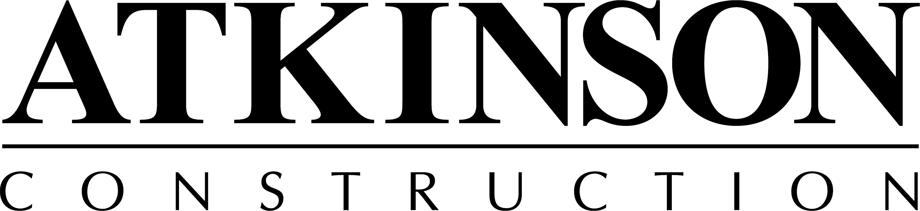
We are an Equal Opportunity Employer
& committed to a drug-free work site.

#GUYFACL003R8

