Washington State Patrol

Request for Proposal (RFP) #: RFP WSP DEI2021

Title: WSP WORKFORCE DIVERSITY, EQUITY & INCLUSION STRATEGIC RECRUITMENT PLAN 2021

PART 2 PAST STUDIES

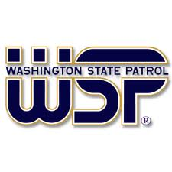

PART 2 Past Studies

NOTE: Interested Bidders are encouraged to preview the past studies prior to preparing and submitting a proposal. The past studies are available below for Bidders to preview.

