Sub Bids Requested for
SR 509, I-5 to 24th Avenue S. – New Expressway Project
Owner: WSDOT
UDBE Condition of Award Goal: 8% of Design
UDBE Condition of Award Goal: 10% of Construction
FSBE (Federal Small Business Enterprise) Condition of Award Goal: 8% of Design
FSBE Condition of Award Goal: 13% of Construction

Bid Date: October 8th, 2020 at 11 am (PDT)
Subcontractor Bids Requested: October 6th, 2020 at 5 pm (PDT)
Atkinson in association with Jacobs is bidding the above referenced Design Build project as a prime contractor. We are committed to supporting, assisting and providing equal opportunity to UDBE and FSBE Business Enterprises. In furthering that commitment, we invite all Subcontractors and Suppliers to bid on the referenced project.
Project Description: The purpose of this Project is to provide a critical north-south corridor alternative to I-5 through Seattle and South King County. The corridor will complete critical freight links, reduce traffic congestion, provide and alternative airport access from the south, and support regional job and economic growth. The Project includes constructing SR 509 from I-5 to 24th Avenue S., including the interchange with I-5. On I-5, the Project constructs improvements along approximately 2.5 miles from S. 200th Street to SR 516.
Services, Supply and Subcontractor Opportunities Include: flatwork, concrete supplier, aggregate supplier, sawcutting, landscaping, traffic control, survey, trucking, girder hauling, concrete pumping, HMA paving, bridge demolition, signage, pavement markings, guardrail, erosion and sediment control, building demolition, rebar, earthwork, drainage, water line, barrier, structural steel, coating/painting, sweeping, steel supply, steel fabrication, retaining walls, slope protection, design services and more.
Project Documents: https://www.wsdot.wa.gov/biz/contaa/Contracts/SR509completion.html, documents can be downloaded at no cost.
Submit Quotes to
Attn: Stephanie Anderson
707 S. Grady Way, Ste. 500,
Renton, WA 98057
Tel: (425) 255-7551, Fax: (425) 255-7325
Email: nwestimating@atkn.com

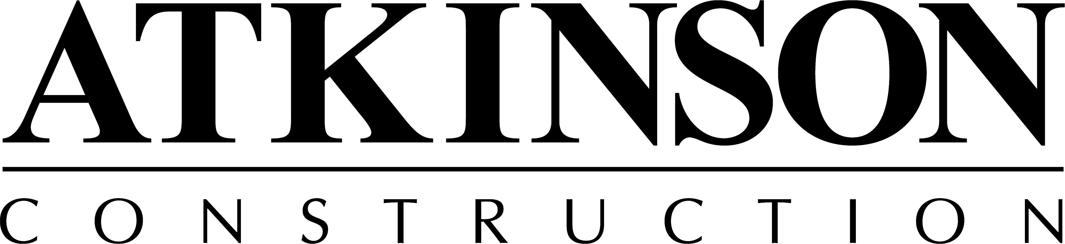
We are an Equal Opportunity Employer
& committed to a drug-free work site.
#GUYFACL003R8

